Problem:
Φ Create any database and in such database create a table named employee with the
following columns by considering employee_id as primary key
employee(empoyee_id,first_name,last_name, age,address, department,postion,salary)

MariaDB [(none)]> create database employee;
MariaDB [(none)]> use employee;
Φ Now insert at least any 10 records of employee.
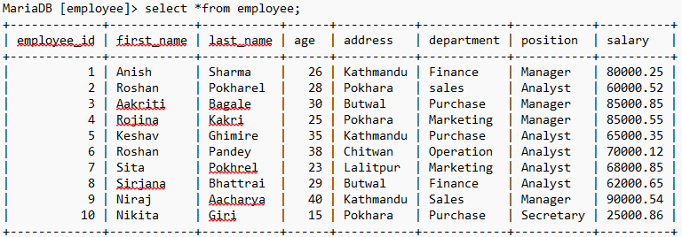
Now, Write a query to perform the following operations
Arithmetic, logical and relational operators
1. Display the first_name and last_name of employee whose deparment is finance

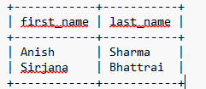
3. Increment the salary of all employees by 15%

2. Display all the information of employee in employee table whose address is not kathmandu
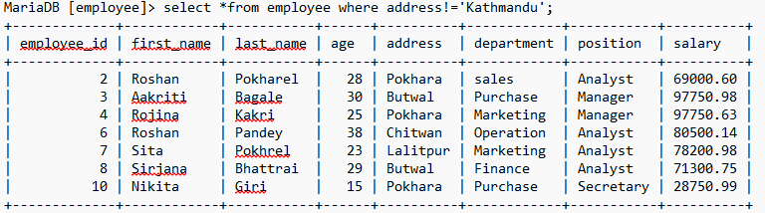
4. Decrease the salary of manager by 5%

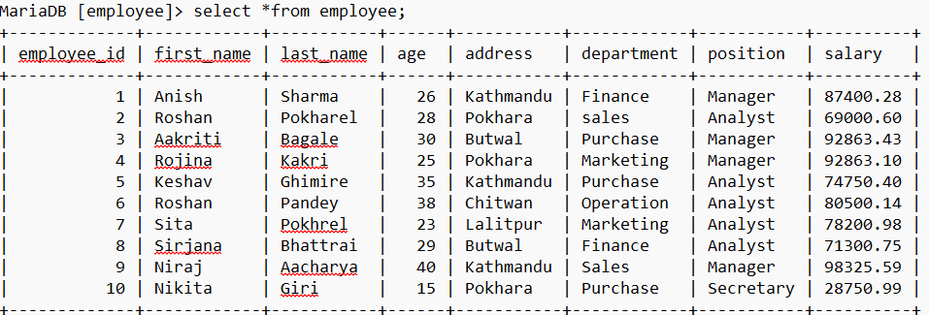
5. Delete information of employee whose age is less than 18

6. Display the position of employee whose salary is greater than or equals to 50000

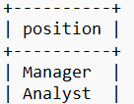

7. Display information of employee whose position is manager and address is kathmandu
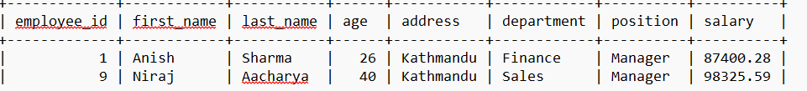
8. Display information of employee whose positon is manager or address is Kathmandu;
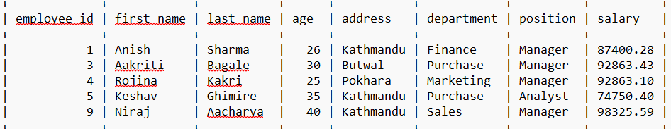
9. Display information of employee who either live in pokhara or kathmandu but age is greater
than 25.
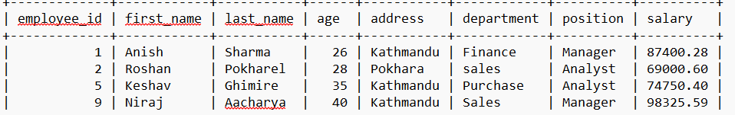
10. Display first_name,last_name and position of employee whose salary is in the range of
70000 to 80000
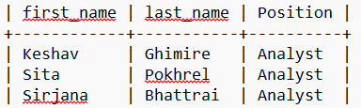
11. Display first_name,last_name and position of employee whose salary is not in the range of
70000 to 80000
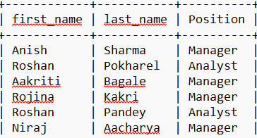
12. Display the information of employee whose salary is equal to
69000,30000,35000,40000,71300,80500
Empty set
13. Display information of employee whose department is (sales, purchase ) but not salary
equal to (69000,71300,80500) Like operator with wildcard characters.
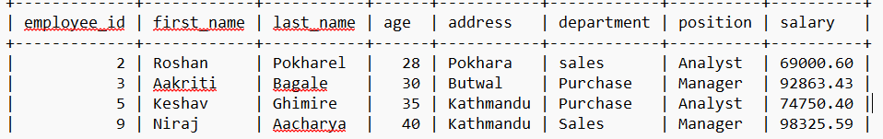
14. Display information of employees whose first_name starts with letter ‘a’
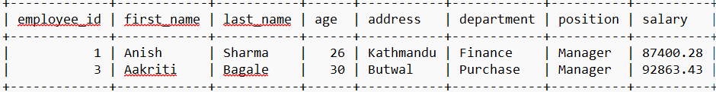
15. Display information of employees whose first_name starts with letter ‘ro’
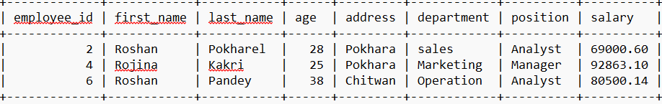
16. Display information of employees whose last_name ends with letter ‘el’
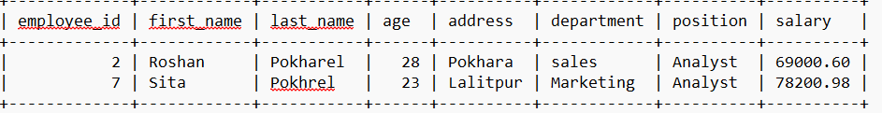
17. Display information of employees whose first_name has exactly six characters
Syntax
Output:
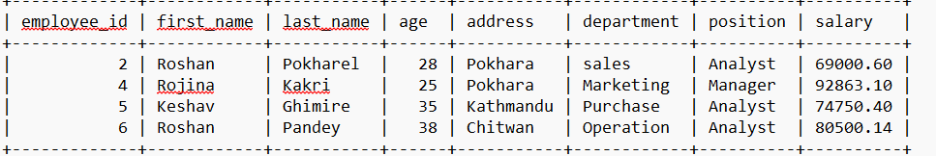
18. Display information of employees whose first_name starts with r and has exactly six
Characters
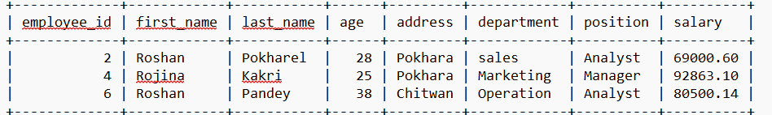
19. Display the information of employees which contains substring of first_name as ‘sha’

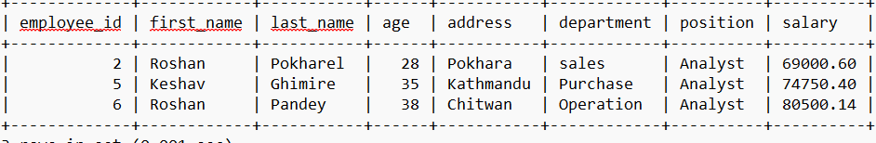
20. Display information of employees whose second position of first_name contains letter ‘o’
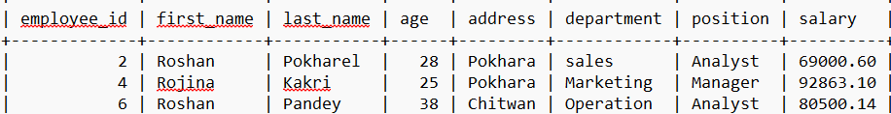
21. Display information of employees whose third postion of first_name contains the letter ‘s’
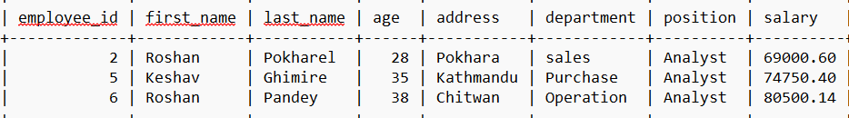
22. Display information of employees which have first_name of at least six characters
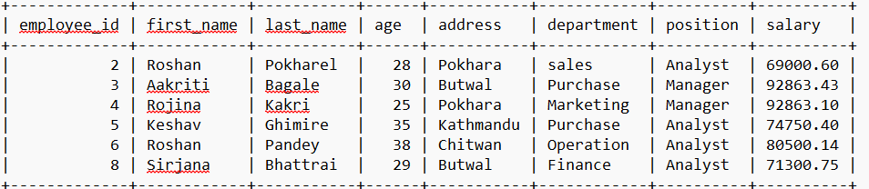
23. Display the information of employees whose first_name begins with a,k,m,s,r .
MariaDB [employee]> select *from employee where first_name like '[akmsr]%';
Empty set (0.001 sec)

24. Display information of employees whose first_name begins with [a-s] and ends with l
MariaDB [employee]> select *from employee where first_name REGEXP '^[a-s]%l';
Empty set (0.001 sec)
25. Display information of employees whose first_name does not start with d but ends with h
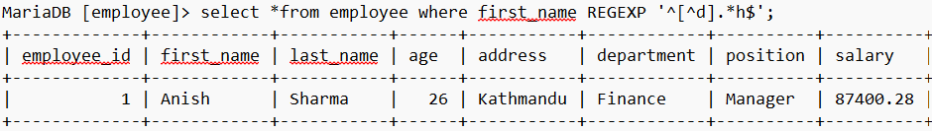
DISTINCT
26. Display the different position available for employee
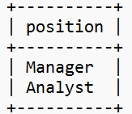
27. List out the unique address available for employee table
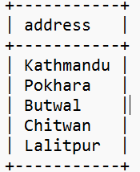
28. List out the employee who have unique first_name and address
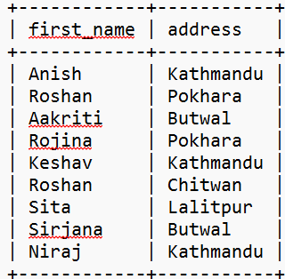
AS
29. Write a query to get first_name,last_name , ssf of all employees .ssf is calculated as 31% of salary
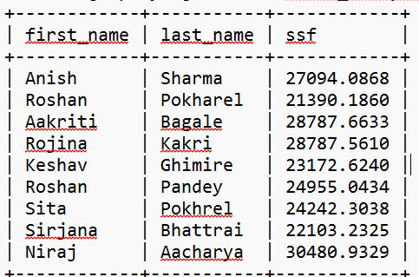
30. write a query to get the employee _id, name (first_name, last_name), location (address) from employee
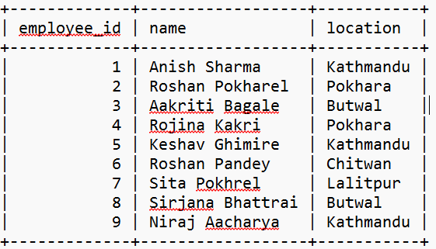
ORDER BY
31. Display the information of employees in ascending order by address
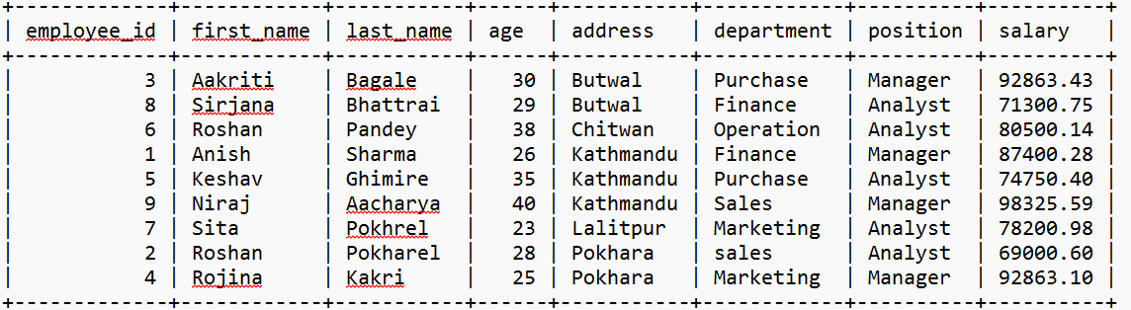
32. Display the information of employees in descending order by address
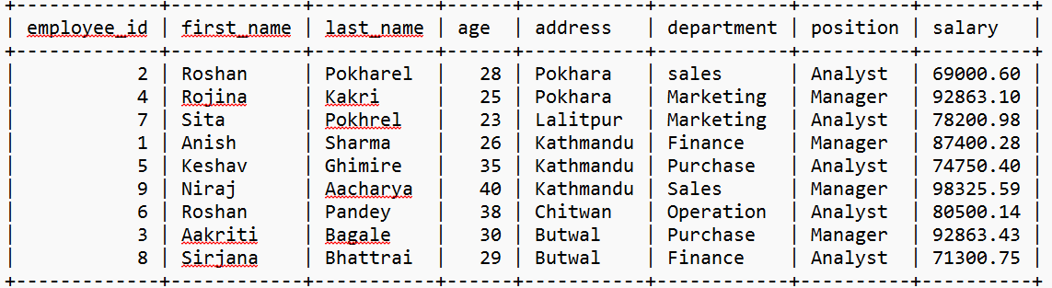
33. Display the information of employees in ascending order by address and department
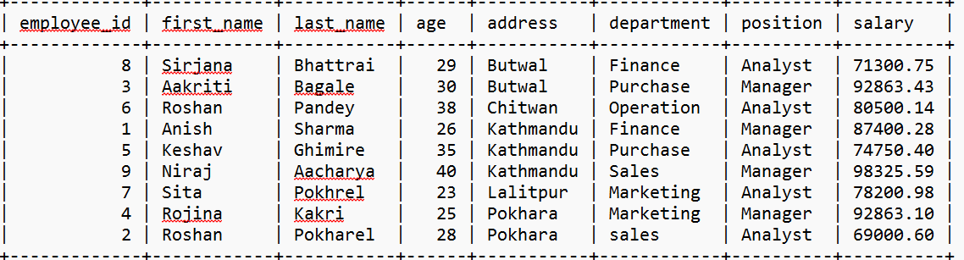
Aggregate functions
34. Count the number of employees
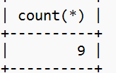
35. Count the number of unique first_name of employees
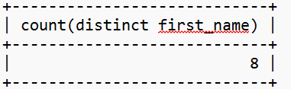
36. To get the number of different number of positions available for employees table
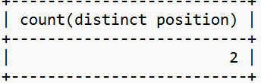
37.To get the total salaries payable to employees
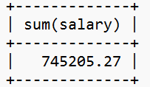
38. Find the average salary of employess
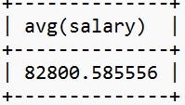
39. Find the minimum salary of employess
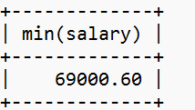
40. Display first_name, last_name of employees with highest salary
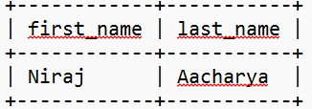
41. Display first_name,last_name,department,postion whose salary is less than average salary of all employees
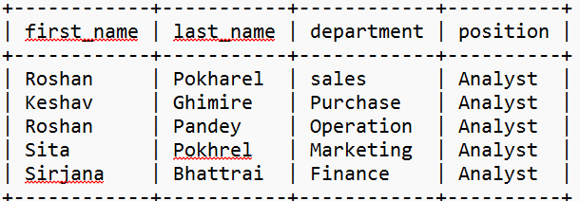
GROUP BY and HAVING clause
42. Find the average salary of employees in each department
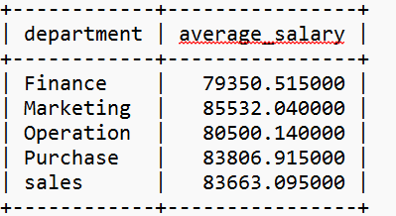
43.Find the average salary of employees for each position

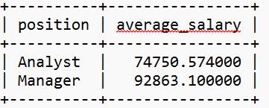
44.Find the department with their average salary is greater than 60000
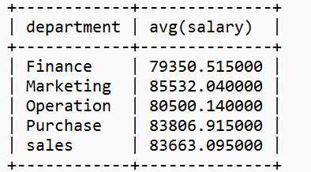
45. Find the position of the employee in which average salary of position is greater than 60000
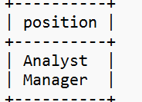
Subquery
46. Display information of employee whose salary is greater than average salary of all employees
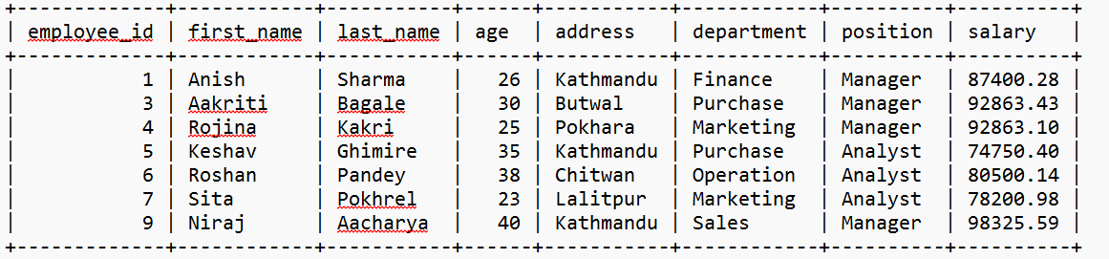
47. Display information of employee whose salary is greater than at least one employee of finance department.
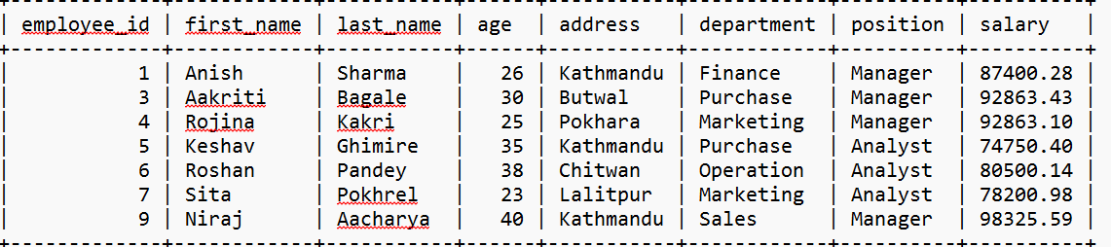
48. Display information of employee whose salary is greater than that of all employees of finance department.
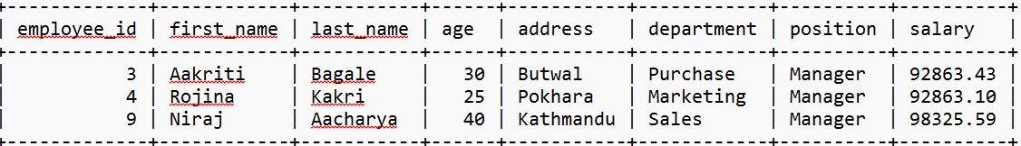
49. Increase the salary of employees by 10% whose salary is greater than the average salary of all employees.
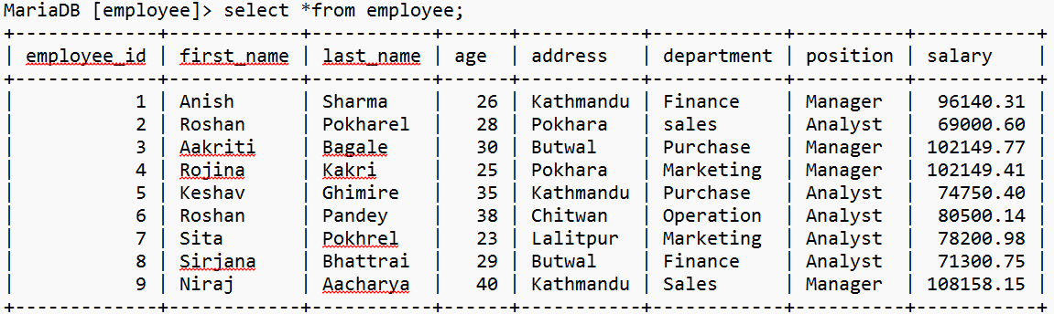
50. Delete the information of employees whose salary is less than average salary of all employees.
